Version 3.0

December 10, 2015

Will Rodriguez

Sergio saucedo



SkillCourt

# Table of Contents

Table of Contents 1

Introduction: 2

SkillCourt Android Application 3

Installing Android Studio 3

Arduino Microcontroller 4

Arduino IDE 5

Setting up Arduino Microcontroller 5

SkillCourt Simulator and Routine Wizard 6

Processing IDE 6

SkillCourt Website 7

Resetting ec2-user Key Pair 7

Reset Domain Name Server 8

Installing XAMPP 8

# Introduction:

This document will provide a comprehensive set of steps that allow any developer to set up the environment in his or her development machine in order to start working with the SkillCourt application. This guide also includes a comprehensive set of steps to run the application and test it in an Android device, as well as a list of the technologies that need to be installed in order to keep the development of the application moving forward. Additionally, it includes step-by-step information of how to access and run the SkillCourt website in the development machine. There are also instructions that will help in the development of the Arduino microcontroller. Lastly, instructions of how to get the current SkillCourt Project from GitHub are included

## 

# SkillCourt Android Application

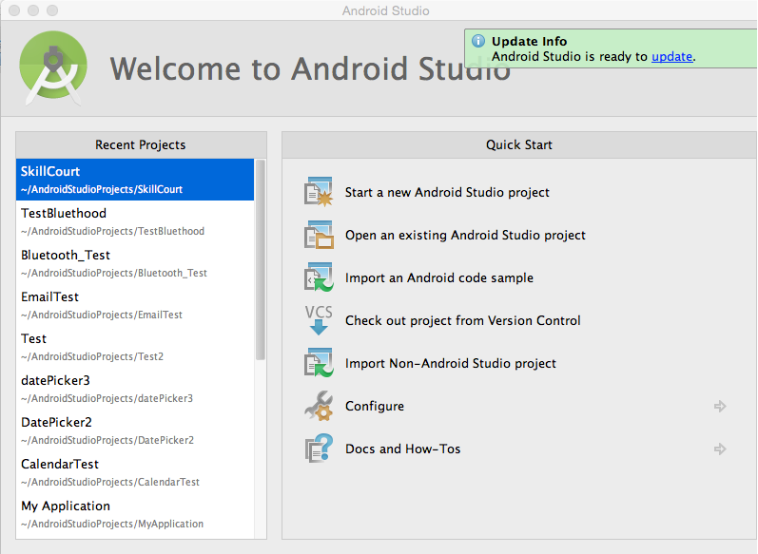

Note: The SkillCourt Application makes use of a phone’s Bluetooth feature. To properly test, an Android Device is necessary. An AVD will not be able to connect with the Arduino controller.

### Installing Android Studio

1. First you will need an IDE for Android Application Development. This guide will use Android Studio. Follow the link: <http://developer.android.com/sdk/index.html> . Then click “Download Android Studio”. Accept the terms and conditions.
2. Once the download is complete, open the application and continue through the steps shown.
3. Once Android Studio is installed, you must install the necessary SDKs. Click on the Android SDK Manager icon: In the menu, select the checkboxes by API 21, API 20, and API 19. 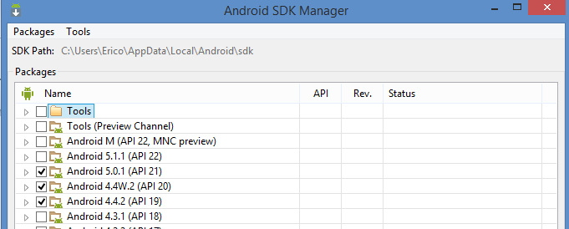
4. Then continue by clicking on Install Packages. Accept the terms for the downloads and continue.
5. Once the SDKs are installed, you can find the location of the SkillCourt project found in SkillCourt-Backend/Code and open it in Android Studio by selecting File 🡪 Open.

# Arduino Microcontroller

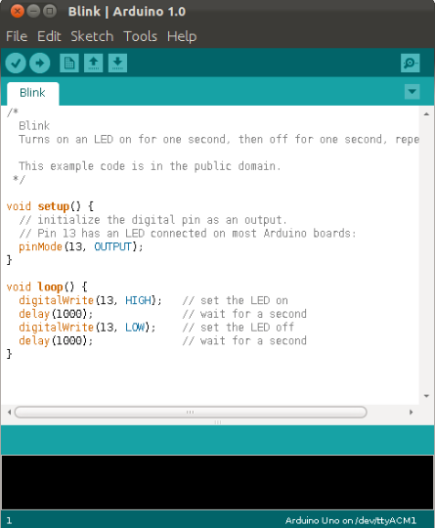

### Arduino IDE

1. In order to be able to work with Arduino navigate to the following webpage: <http://arduino.cc/en/main/software>
2. Then, select the operating system running on your development machine and click download.
3. Once you have Arduino IDE running in the development machine, connect your Arduino to the computer via a USB connection.

Once code is written, press run and select the Arduino microcontroller in which you will be running the code.

### Setting up Arduino Microcontroller

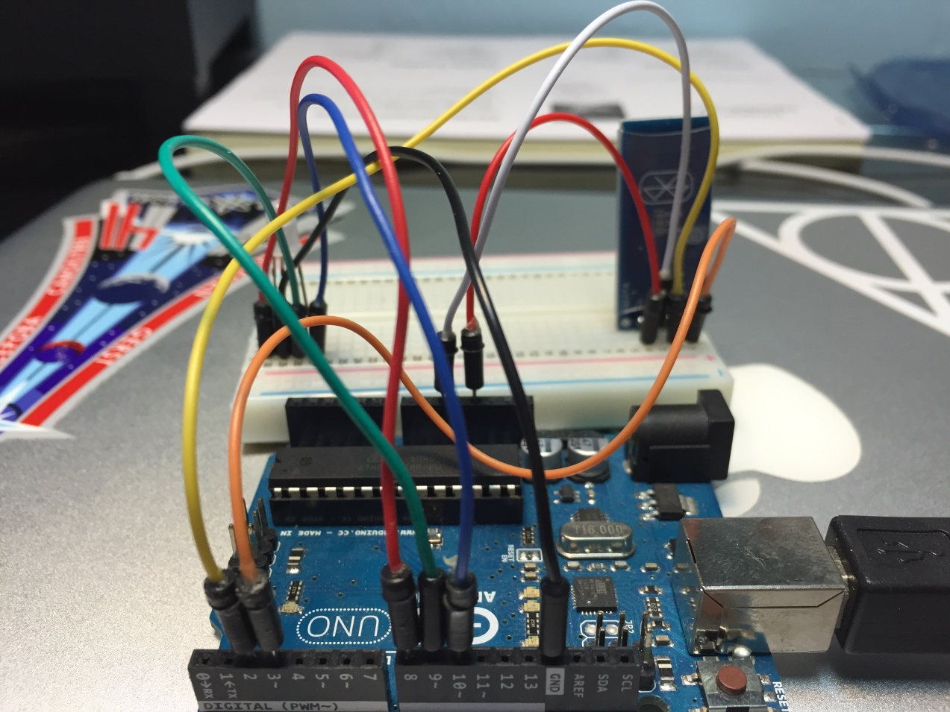

|  |  |
| --- | --- |
| Connections between Arduino pins and Bluetooth Module pins: | |
| Arduino pins | Bluetooth module pins |
| 5V | VCC |
| Ground | Ground |
| 2 | TXD |
| 3 | RXD |

|  |  |
| --- | --- |
| Connections between Arduino pins and LED pins: | |
| Arduino pins | Bluetooth module pins |
| 8 | Red LED pin |
| 9 | Green LED pin |
| 10 | Blue LED pin |
| Ground | Ground |

# SkillCourt Simulator and Routine Wizard

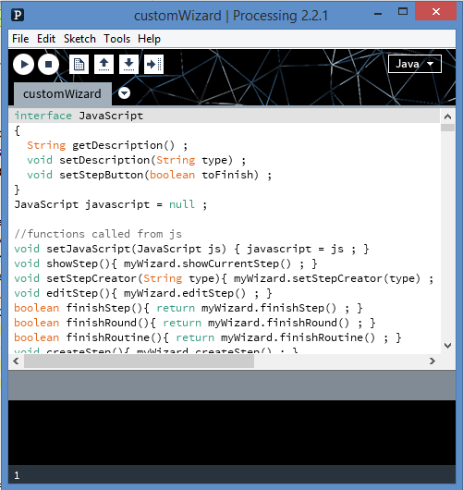

These sketches are developed using Processing. We use two versions of Processing for the sketches: Processing (Java-based) for the desktop Simulator that connects with the Android Application and Processing.js (JavaScript-based) for the Simulator and Routine Wizard found on the website. To install Processing:

### Processing IDE

1. Follow the link <https://processing.org/download/?processing>
2. After downloading, extract the files from the zip download.
3. Run the processing.exe executable
4. To add the JavaScript mode, click on the drop-down menu on the top-right that says Java. Select “Add Mode…”, click on “JavaScript Mode” and install.
5. Now you can open the Desktop Simulator by opening the file at:   
   SkillCourt-Backend/Code/Simulator/Simulator.pde   
   And the online files on JavaScript Mode at: SkillCourt-Backend/Code/html/simulator/simulator.pde SkillCourt-Backend/Code/html/customWizard/customWizard.pde

# SkillCourt Website

Currently, the website is hosted on Amazon Web Services. The domain “skillcourt.com” is hosted by GoDaddy. The credentials for these will be supplied by your product owners. The AWS console will allow you to access the information and configuration settings for the EC2 instance.

### Resetting ec2-user Key Pair

Only one of you may do the following,

1. Enter the EC2 Console on AWS using the SkillCourt credentials
2. Stop the current running instance of SkillCourt
3. Detach the /xvda volume from SkillCourt in the volumes tab on the left
4. In the key pairs link on the left, create a new key pair
5. Create a new micro instance using your new key pair
6. Attach the /xvda volume to the new micro instance as /dev/xvdf
7. ssh into the new instance you have created
8. Mount /xvdf to the new instance by running the following $ sudo mkdir /mnt/tmp $ sudo mount /dev/xvdf1 /mnt/tmp
9. Now you can copy your new key pair into /xvdf by running $ cp ~/.ssh/authorized_keys /mnt/tmp/home/ec2-user/.ssh/authorized_keys
10. Exit the session
11. Detach the volume /dev/xvdf from the instance you created and terminate the instance
12. Attach the volume back unto the SkillCourt instance and name it /xvda
13. Now you can ssh into the SkillCourt instance with your own key pair

After changing the key pair for the instance you will have to enter GoDaddy so the domain will reroute properly

### Reset Domain Name Server

1. Create a GoDaddy account and get access from your product owners to the SkillCourt domain
2. Open email granting you access to domain and click the “Log In” button
3. Click on the access button under “GUDMUNDUR”
4. Under the Products tab, click Manage by Domains
5. Under skillcourt.com, click Manage Connection
6. Click Update Forwarding and enter the new public DNS for the instance (can be found in the EC2 console under ‘instances’)

### Installing XAMPP

To be able to test web code locally you will download XAMPP

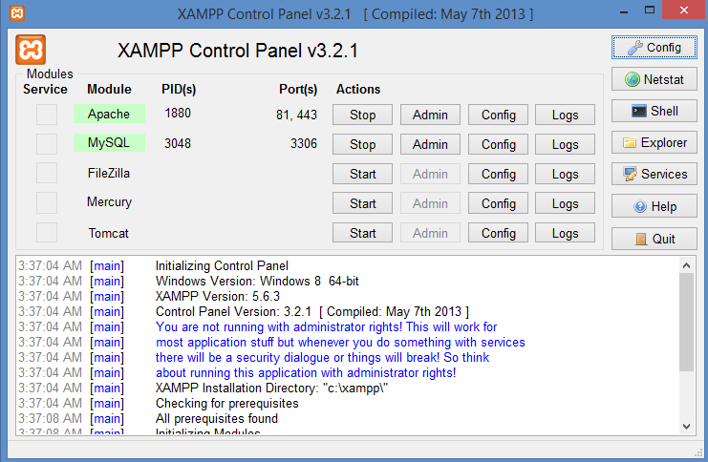

1. Follow the link <https://www.apachefriends.org/download.html>
2. Click on the download link that is appropriate for your machine.
3. After going through the installation open the XAMPP Control Panel as shown above. Here you will Start the Apache Module.
4. In order to test your files locally, place the desired files in the htdocs folder within the xampp folder which is found in the C:\ drive on Windows.
5. In a web browser’s address bar, enter

localhost:{apache port number}/{path to file} where {path to file} is within htdocs